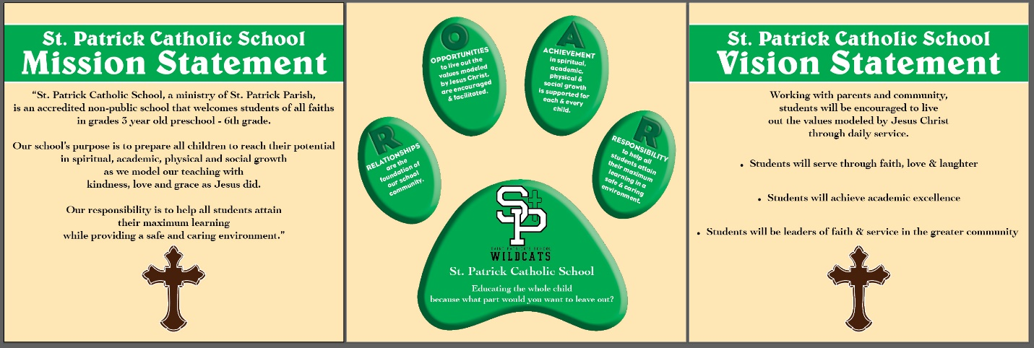

Oct. 12, 2020
Dear St. Patrick School Families,
We are very pleased that we have completed 7 weeks of school with face-to-face instruction every day with minimal positive Covid-19 cases. These incidents have required administration to work with families and public health to complete contact tracing and quarantine additional students and staff. Our number one goal is to keep our students in school this year as much as we possibly can. We do not wish to close our building or quarantine large numbers of students.
Therefore, we are making an upgrade concerning face mask wearing from recommended to expected. Shown below is an explanation of the new procedure issued by the Governor’s Office in conjunction with the Iowa Department of Public Health and the Iowa Department of Education.
The Iowa Department of Public Health is making a change on quarantine recommendations for people that have been exposed to a positive case of COVID-19 in school. Close contacts of COVID- positive cases will no longer need to quarantine for 14 days if a mask was worn consistently and correctly by the positive case and close contacts. The positive case must isolate. The close contacts should self-monitor.
● Self-monitoring entails close monitoring for COVID-19 symptoms over the subsequent 14 days, staying home if any symptoms develop, and speaking with a healthcare provider about COVID-19 testing in the case of any illness.
● If people who are self-monitoring become ill but do not get tested, they should remain home until 10 days after symptom onset.

Families will continue to be notified of any close contact with a COVID positive case even when masks are worn consistently and correctly. You will only be asked to quarantine your child for the following reasons:
● If the positive case wore a mask, but close contacts did not, those close contacts must be quarantined.
● If the positive case did not wear a mask, close contacts must quarantine whether or not they wore a mask.
● Quarantine of close contacts will still be necessary in residential and healthcare settings.

Masks have been shown to be effective in preventing the spread of COVID-19. Increased mask use will reduce the number of individuals that need to quarantine. Along with wearing a mask, we ask that everyone continue all recommended public health strategies.

● Stay home when sick.
● Maintain social distancing of at least 6 feet whenever possible.
● Wash hands frequently.

This approach is based on data and focused feedback from the community and school leaders over the past month indicating that transmission is not frequently occurring when both parties are wearing a mask consistently and correctly. Neck gaiters or face shields are NOT appropriate face coverings according to the CDC and the Iowa Department of Public Health.

This is considered a school expectation and we will rely on the cooperation of all involved. We are not calling it a requirement or imposing a penalty on those that do not choose to follow this expectation. We wish to preserve your right to make your own choice and try this approach. Again, we are trying our best to keep school open for all. Thanks for your consideration.

Please continue to pray for the eradication of the coronavirus and all those affected by this illness. As always, please contact me you have any questions or concerns.

Sincerely,

Katie Fahey, Principal
kfahey@st-pats.pvt.k12.ia.us
563-568-2415

